**Analysis: Task #04 (Syeda Simel)**

I checked my webpage on several browsers like Chrome, safari, fire fox and edge

The basic functionality, working and layout on the browsers were working totally fine.

Then **I did a deep analysis comparison of my webpage with Chrome (primary used browser) and Edge** and there were no errors or issues in Chrome but there were some in Microsoft Edge.

**Chrome Screenshot;**

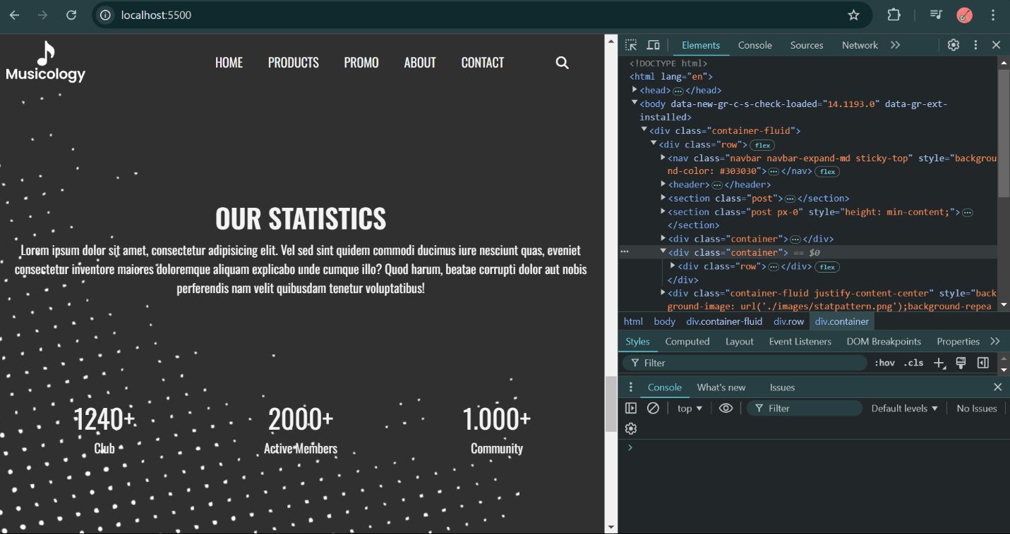

As you can see**, no error** or issue is there.

**Microsoft edge screenshot;**

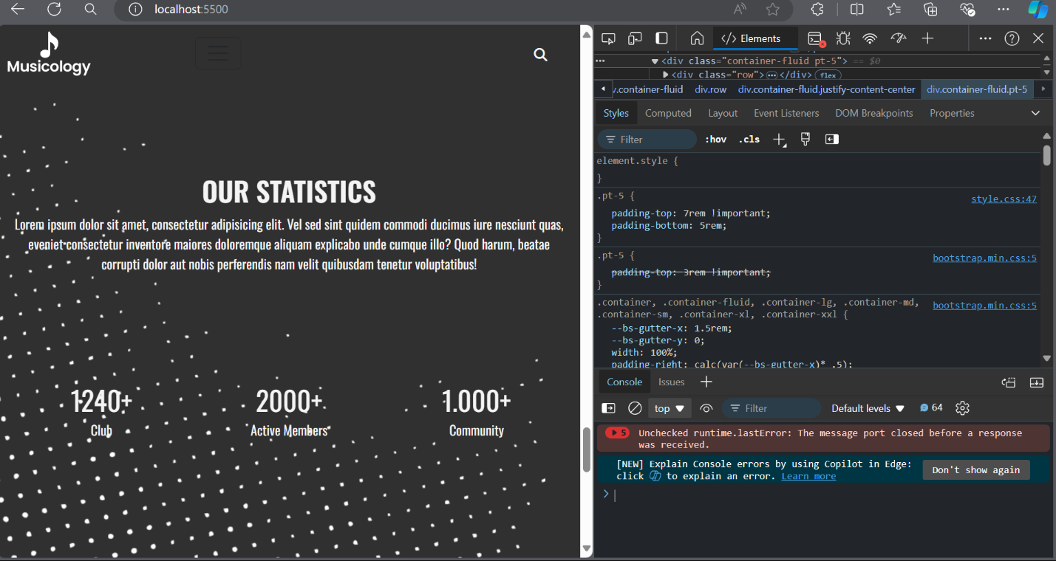

So, this **error** was coming up**, I resolved** it by turning off some unnecessary extensions.

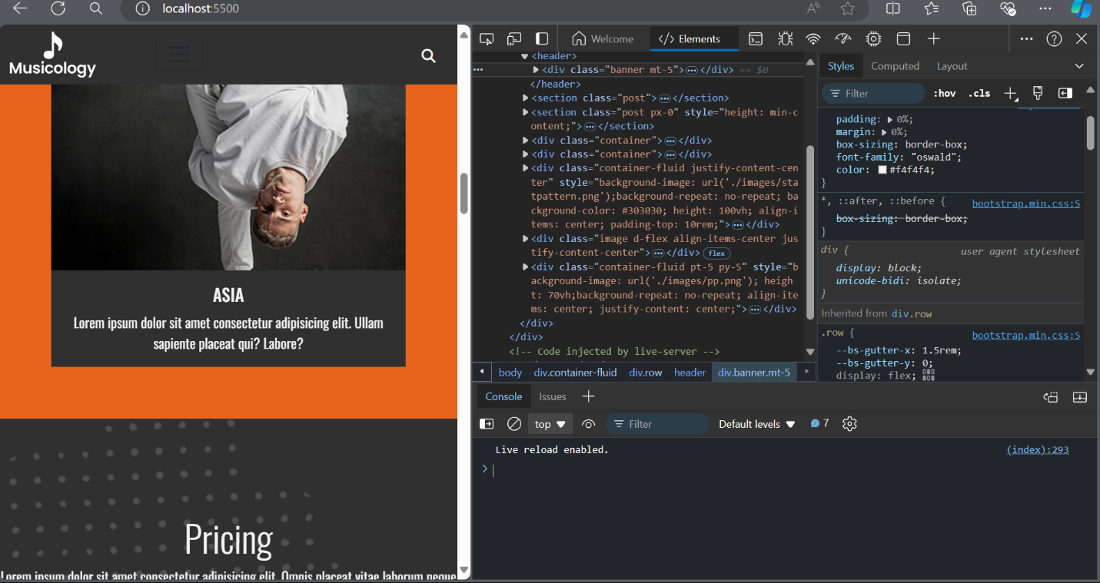

Then, I checked issues (filter: top browsers) and there were some;

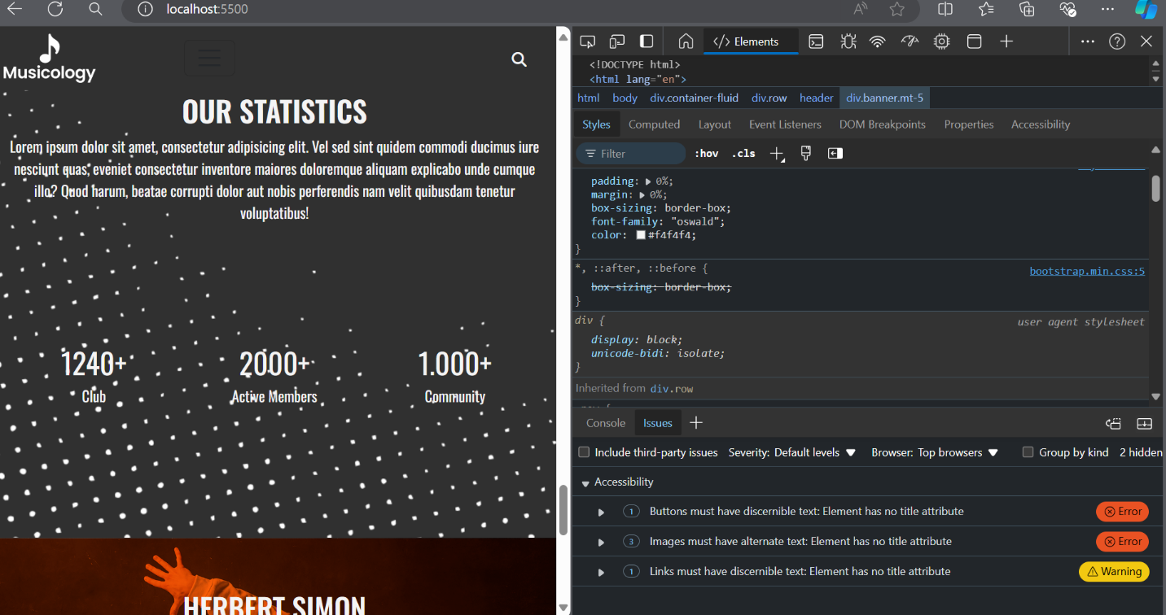

There were **multiple issues with error** and waring level.

**I resolved it** with using the tags like “aria-label” and adding “alt” in my images.

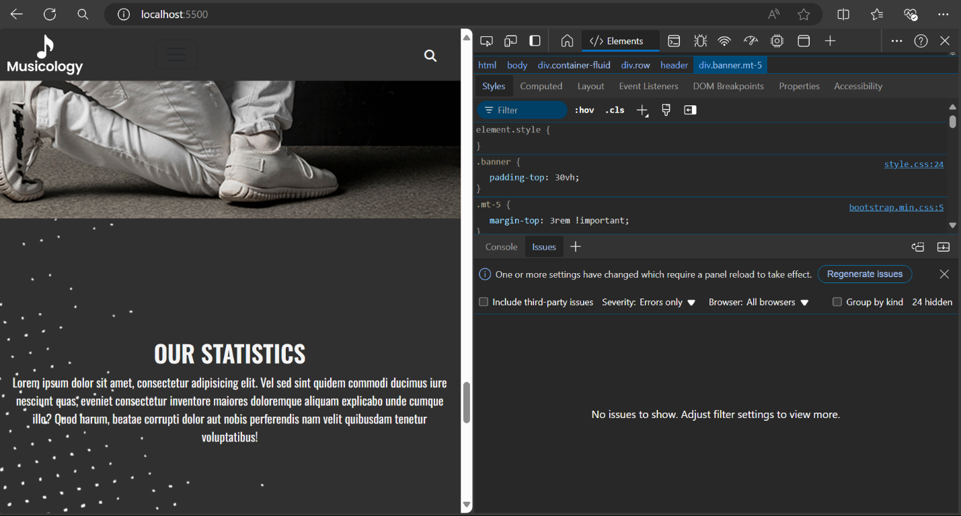

**ALL ERRORS are solved with the filter ALL BROWSERS as you can see.**

Screenshots from other browsers as well to check functionality, performance and layout;